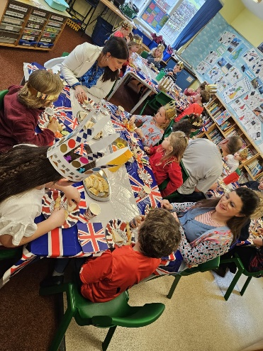
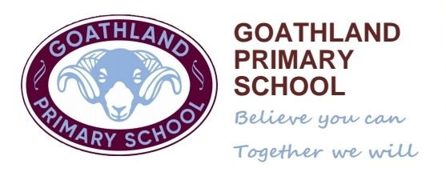

Diary Dates
8th May BH – Coronation Weekend
9th May – Return to School
11th May – Bags to School Collection
18th May – Parent Briefing on Online Safety by NYP at 3.30 pm
24th May – Liz Million Visit
25th May – Scarecrow Birds returned to school deadline.
16th June – School Trip
6th July – Base 2 Trip

5th May 2023
Dear Parents,
Coronation Celebration
Thank you to our cook, Mrs Brown, for our Coronation Celebration lunch. The cakes were a definite favourite! We hope you all enjoy this extra-long celebration weekend. The Goathland Village Beacon will be lit at 8.00 pm tonight outside the Village Hall and everyone is welcome at the Village Hall tomorrow for the Coronation Party. The children’s crowns and King Charles portraits will be displayed inside the hall for everyone to see.
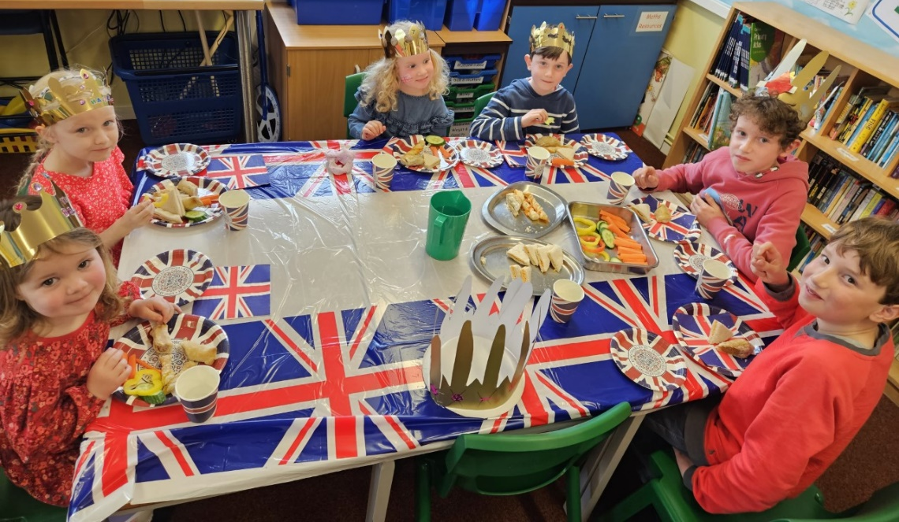
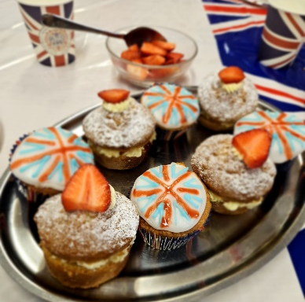
It has been a delight to welcome two new children to our Goathland school family this week. Both have settled well into their respective classes and all the children have enjoyed getting to know their new friends.

Base 1
Weeks are already flying by in Base One!
In Literacy we have been reading and writing about Jack and the Beanstalk, all children have really enjoyed this text. Year One children have been trying hard to write independent sentences using word banks and conjunctions. Our younger children have enjoyed mark making and writing captions. In addition to this, we planted our own ‘magic beans!’
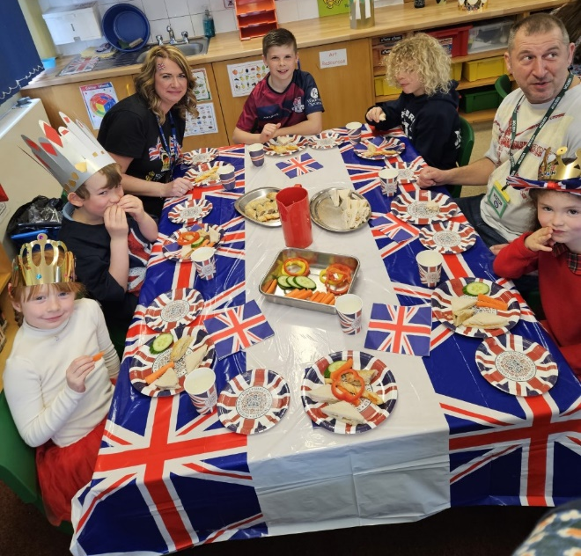
Our Royal text this week also enthused us about the Coronation and the children enjoyed learning more about The Royal Family.
In Maths Year 1 have been learning about fractions of shapes and then amounts. We did this in practical ways to help!
EYFS children are becoming more secure with number recognition and making amounts.
In PE the children are becoming more confident at throwing and catching skills. It has been wonderful to watch the children being ‘free’ in such a large open space. We are so lucky to be able to use The Hub.
In History the children are engrossed with our new topic about ‘The Fire of London’. We have been singing songs about it and we will be linking our artwork into this topic too.
Thank you for your support for reading at home, it really makes a difference when we work together.
Base 2
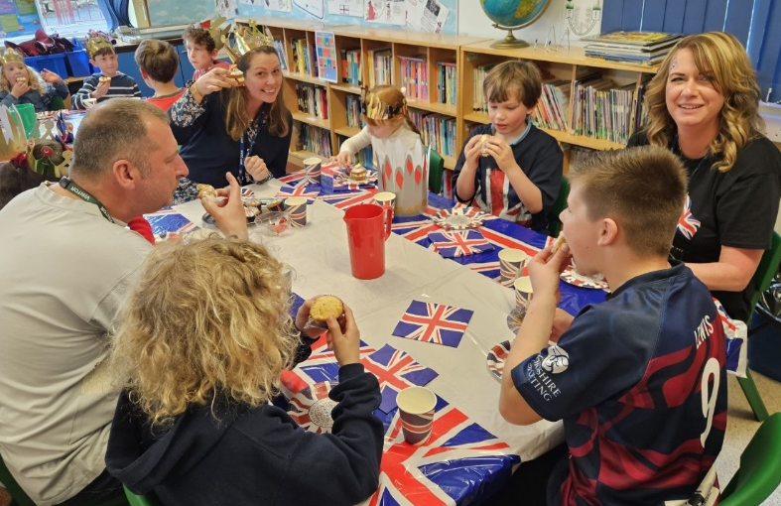
These last couple of weeks have brought both our Science and Geography topics to an end. The children thoroughly enjoyed investigating irreversible chemical changes in science and their assessments showed they have all learnt a lot about the properties of materials over the last few weeks.
The children finished their Geography topic by learning about grid references. Initially they used these to locate specific features on a map, then they used both compass directions and grid references to plan different routes on their maps. Thank you to the Fitzgerald’s who lent us some additional Ordnance survey maps for this.
In literacy the children have been taking inspiration from Frostheart to plan and draft their own adventure stories. They will be editing and publishing these before half-term.
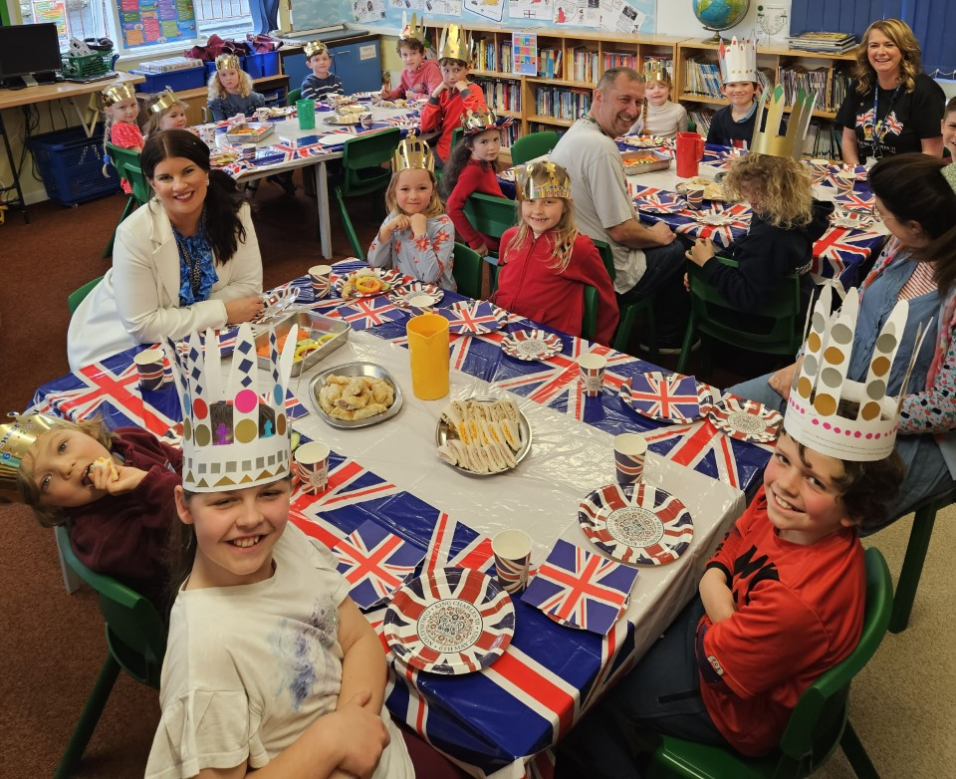
Making healthy choices for both our bodies and minds was the focus in PSHE this week. Alongside revisiting the importance of healthy food and exercise for physical health, the children discussed the importance of things such as hobbies, friendships and talking about feelings to support their mental health. The older children also explored some of the possible negative effects social media can have on mental health.
Coding is our computing focus this term. This is ongoing and year group specific as the coding challenges get progressively more complex. In conjunction with the practical coding activities the children have teacher led sessions where they are taught specific vocabulary and wider computer skills.
Base 2’s Art project, to use different techniques and media to create pieces of art based on the natural and man-made features in our local environment, was delayed while the children created some art to celebrate the King’s Coronation. This week they have finally begun by making paper collages of the façade of our school building then adding sketches of smaller additional features to add depth to their work.
P.E.
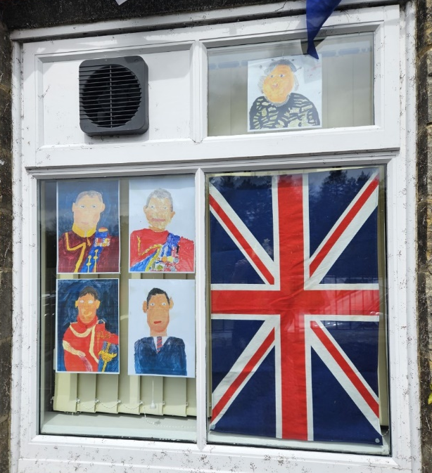
All the children have enjoyed their first two P.E. sessions at the Hub field, it’s great to have so much space to run around in! Like last year they will be working on specific running and jumping skills to gain their English Schools Athletics Association certificates but we have also been practicing ball skills and playing cricket style games.
Whole School.
Last Friday our local PCSO, Pete, came to speak to all the children about online safety. Although this is something we regularly address both in our PSHE and computing lessons it is a very important area of safeguarding in the modern world and having a PCSO talk to the children helps to emphasise this. The children enjoyed his visit and we would like to thank him for spending the afternoon with us.
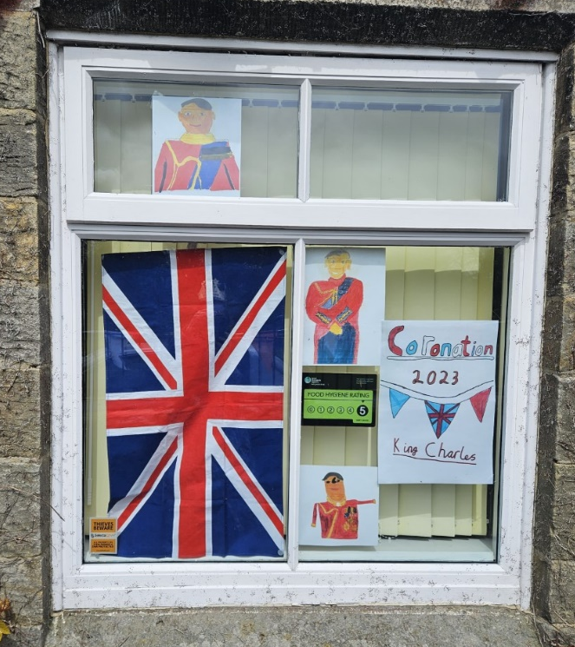
Bags2School
Please use this long weekend as an excellent opportunity to spring clean your wardrobes. Clothes can be dropped off in bags on Wednesday 10th May at 3.15 pm or first thing on Thursday 11th May. The more clothes we can collect for recycling the more money raised for our school.
- Men’s, ladies’ & children’s clothing, paired shoes, handbags,
- belts & accessories.
- (No uniforms, workwear, pillows, duvets or pieces of fabric please)

From the Staff at Goathland School.

