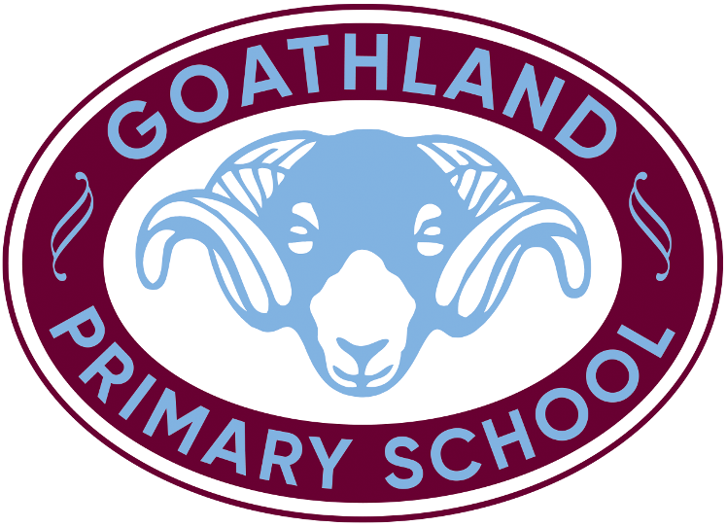

Curriculum Policy for Goathland Primary School

Effective Date: | May 2020
Adopted by the Governing Body | December 2020
Reviewed | March 2025
Next Review Date | March 2026
Approved By: | The Governing Body
Chair of Gov | Mr Nick Chambers 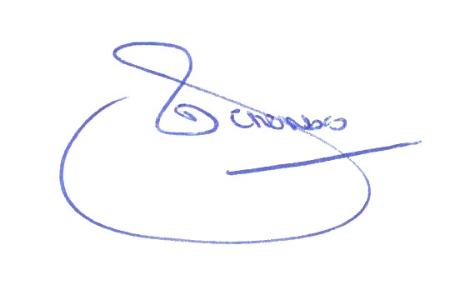

Rationale

Goathland Primary School is a small, rural primary school which is attended by children from the local village and its wide catchment area, as well as those from neighbouring villages.

The school is situated on the edge of the North York Moors national park and the children benefit from having easy access to the local environment. This includes our own Forest School field; a beautiful area of natural woodland which offers a unique environment for outdoor learning. Our enviable location provides many opportunities for experiencing aspects of the science and geography curriculum first hand. We appreciate the advantages that our setting offers. However, we are also aware of potential barriers to learning it presents.

The nearest town is 9 miles away and the nearest large city is 40 miles away. Some children have limited opportunities to benefit from cultural experiences, for example, visiting museums, galleries or the theatre. In addition, the school and the surrounding areas do not reflect the diverse, multi-cultural make-up of British society. It is vital that the school fosters a comprehensive world-view and encourages all children to be outward looking. We need our children to develop positive attitudes towards diversity and to celebrate difference. The school recognises the importance of providing opportunities to learn about and develop a deep understanding of other cultures and to experience cultural traditions beyond their own.

The school is small so the children and staff develop strong relationships and they know each other very well. This is a strength of the school but we are also mindful of the need to develop the children’s self-confidence and resilience in order to prepare them for the next stage in their education when they move to larger secondary schools and beyond. As such, we engage in a range of inter-school sporting activities and residential learning opportunities to broaden friendship groups.

The school is also aware that these children will be living and working in world of rapid changes. We can help to prepare them by, not only ensuring that they have strong computing skills, but also by developing their skills in collaboration, adaptability, flexibility, determination, resilience, and their ability to be independent and reflective thinkers, articulate speakers, and responsible, caring citizens. Visitors to our school have told us that our children are confident and articulate and we agree.

We strive to provide a curriculum that is deep and rich; bespoke to our children’s needs and inspiring a life-long passion for learning. We focus on providing learning opportunities which are engaging and relevant, with the aim of motivating all children to expect and achieve success. Our curriculum builds on the knowledge, skills and cultural wealth of our community, with a commitment to developing children as individuals and as global citizens. Our curriculum vision is to provide a fully inclusive education, which ensures that all children are well-equipped to succeed in the modern world.

Intent – What is taught in our Curriculum?

- Our curriculum is an engaging, high quality curriculum, firmly based on the National Curriculum
- As a small school with mixed age classes we have created a `spiral curriculum’ to ensure that the skills and knowledge sequence increase in complexity as our children develop in their learning and progress through our tracking system
- We follow a two year rolling programme for KS1 and a four year rolling programme for KS2 to ensure breadth and balance through a child’s time in primary school
- The curriculum utilises the opportunities offered by our locality and communities (e.g. strong links with the North York Moors National Park celebrating the uniqueness of our locality) and addresses the constraints of our rural area (e.g. RE curriculum ensures wider coverage of World Religions than is required, to address the lack of diversity in our schools and communities)
- Reading is a priority in our school to allow pupils to fully access all other curriculum areas
- Mathematical fluency and confidence are also considered to be fundamental for our children’s success
- Teachers are skilled in ensuring that our curriculum can be tailored to be accessible and inclusive for all our learners. They provide access to support when necessary.
- It is our intent to nurture good mental health, well-being and resilience and to equip our children with the skills and knowledge for a successful future life

Implementation - How is our curriculum taught?

- Our curriculum is planned collaboratively through a shared subject leadership project across five local small schools
- Subject leaders have clear roles and responsibilities and assist with planning and moderation of their subjects
- Subject leaders are enabled to develop their knowledge, expertise and practical skill through professional development and training opportunities
- Leaders enable curriculum expertise to develop across the school
- We teach the majority of subjects through engaging cross-curricular topics, ensuring that links are made between subjects but that subjects are clearly identified in their own right
- Some subjects and aspects of subjects may be taught discretely where appropriate or necessary
- Maths and English is taught every day and the opportunity to practise key skills is a priority in all subjects
- Reading is given a high priority to enable children to access other subjects
- Careful planning and differentiation ensure clear progression and help children to build on prior learning
- Learning is sequenced through age related curriculum statements in our medium term planning

- We use our community to provide meaningful and real-life links to learning; promoting future career options and aspirations
- We select appropriate high quality curriculum resources which inspire children and encourage their curiosity
- Resources are adapted to provide access to all
- Opportunities to recap and revisit are built in regularly to assist the children in memorising and consolidating their knowledge
- Leaders at all levels review and quality assure the subject through collaborative moderation, scrutiny and reporting.

Impact – How do we assess and what are our outcomes?

- We assess in accordance with our assessment policy to find out what our children know and can do as a result of our curriculum
- We assess in a way that is informative for our staff but not onerous and in a way that allows us to shape our children’s learning further
- Through collaborative moderation we monitor the reliability of judgements
- Outcomes inform the school’s strategic plan for improvement and can also influence Performance Management and staff training
- We believe our curriculum will enable our children to progress in their knowledge and skills and be well prepared for transition to the next stage of their education

Roles and Responsibilities

The Headteacher will:

- Remain up to date with new initiatives and information
- Drive improvements to teaching and learning
- Review personal and professional development by providing appropriate training and support to ensure a high level of professional expertise
- Build positive relationships throughout the school family
- Have high expectations of self, staff and pupils
- Promote and monitor the progress of all staff and pupils
- Ensure that the school is a comfortable, attractive and safe environment which celebrates and supports pupils learning.

Governors will:

- Support the headteacher in the application of the above
- Monitor the curriculum, teaching and learning and its impact across the school
- Be a ‘critical friend’.

Teachers will:

- Provide a broad and balanced curriculum that develops the skills, understanding and knowledge necessary for future learning
- Promote positive attitudes, good behaviour and moral understanding to nurture self-esteem
- Provide a happy and supportive atmosphere
- Develop lively and enquiring minds through encouraging children to question and discuss issues, in order to make informed decisions

- Provide a stimulating and creative learning environment to encourage each child to aspire to and to achieve the very highest standards
- Celebrate and value pupils’ successes and achievements
- Promote the life-long learning of all members in our school family
- Ensure that they remain up to date and informed in their teaching responsibilities

The SENCO will:

- Ensure that teaching staff are well informed and equipped to meet the above
- Ensure that the curriculum is inclusive and accessible for all
- Maintain an overview of the specific teaching and learning for specific needs
- Monitor the progress of SEND children.

The children will:

- Demonstrate excellent behaviour for learning and respect for all
- Engage positively with extra-curricular activities and homework
- Communicate freely, forming strong relationships across the school.

Support staff will:

- Feel valued and supported in their role, as part of the school team
- Be kept up to date professionally and encouraged to take their learning further
- Support the teacher as stated above.

Parents will:

- Feel welcome in our school and know that they have a fundamental role in our school in helping their child to learn
- Be able to communicate freely with all members of staff
- Engage in curriculum opportunities where able
- Support homework and extra-curricular activities
- Be available for teacher/parent discussions
- Be kept up to date via the school website and social media
- Support their children and the school in the implementation of school policies and behaviour expectations
- Treat children and staff with Respect

Inclusion

Goathland Primary School practises equality of access and equality of opportunity for all its pupils, staff and visitors regardless of; gender, ethnic origin, religious belief, cultural background, ability or disability marital status or sexuality.

Appendices:

- Curriculum Tree
- Curriculum Tree explanation

Subject Appendices:
- English
- Maths
- Science
- Computing
- RE
- DT
- Art
- Geography
- History
- P.E.
- Music
- PHSE

